Red squirrel analysis Table

|  |  |  |  |  |  |  |  |  |  |  |  |  |  |  |  |  |  |  |  |  |  |
| --- | --- | --- | --- | --- | --- | --- | --- | --- | --- | --- | --- | --- | --- | --- | --- | --- | --- | --- | --- | --- | --- |
| Location | N_Prog | | Mean Prog-ng/g | SD  Prog-ng/g | | Max/min | | AOV  Prog  F-val/Pr | | N_Est | | Mean Est-ng/g | SD  Est-ng/g | Max/min | | AOV  Est-  F-val/Pr | N_Cort  Ng/g | Mean Cort-ng/g | SD  Cort-  ng/g | Max/min | AOV  Cort  F-val/Pr |
| Mt. Graham | 47 | | 83.0 | 86.7 | | 317/12.9 | |  | | 45 | | 155 | 183 | 1013/12.1 | |  | 47 | 68.6 | 43.5 | 184/9.79 |  |
| White Mountain | 66 | | 157 | 145 | | 532/20.9 | |  | | 66 | | 376 | 596 | 3525/25.4 | |  | 66 | 155 | 181 | 895/17.4 | 62.91  Pr <2e-16 |
| Phoenix Zoo | 935 | | 27 | 10.1 | | 73.4/3.91 | | 279.5  Pr<2e-16 | | 935 | | 103 | 56.4 | 433/10.9 | | 74.31 Pr<2e-16 | 935 | 52 | 59 | 1084/1.75 |  |
|  |  | |  |  | |  | |  | |  | |  |  |  | |  |  |  |  |  |  |
| Season |  | |  |  | |  | |  | |  | |  |  |  | |  |  |  |  |  |  |
| Fall | 135 | | 28.4 | 27.9 | | 317/3.91 | | 5.532 Pr>0.000917 | | 135 | | 112 | 63.6 | 433/10.9 | | 6.507  Pr>0.000235 | 135 | 44.6 | 51.8 | 592/8.65 | 3.742 Pr>0.0108 |
| Spring | 354 | | 31.7 | 22.6 | | 229/9.89 | |  | | 354 | | 98.2 | 54.9 | 329/12.1 | |  | 354 | 57.6 | 47.8 | 612/3.40 |  |
| Summer | 275 | | 36.6 | 58.8 | | 485/6.14 | |  | | 275 | | 118 | 135 | 1188/25.0 | |  | 275 | 70.6 | 90.2 | 1084/7.37 |  |
| Winter | 284 | | 47.1 | 71.9 | | 532/7.31 | |  | | 284 | | 160 | 288 | 3525/15.9 | |  | 284 | 57.1 | 97.3 | 893/1.75 |  |
|  |  | |  |  | |  | |  | |  | |  |  |  | |  |  |  |  |  |  |
| Location | | N-Test | | | Mean  Test-ng/g | | SD  Test ng/g | | MAX/min | | AOV Test  F-val/Pr | | | |
| Mt. Graham | | 47 | | | 127 | | 65.9 | | 270/34 | |  | | | |
| White Mountain | | 66 | | | 112 | | 104 | | 327/6.94 | |  | | | |
| Phoenix Zoo | | 935 | | | 93.1 | | 30.1 | | 236/47.5 | | 2.095  Pr 0.13 | | | |
| Season | |  | | |  | |  | |  | |  | | | |
| Fall | | 153 | | | NA | | NA | | Na/NA | | 0.005  Pr> 0.946 | | | |
| Spring | | 354 | | | 103 | | 38.4 | | 236/34.0 | |  | | | |
| Summer | | 275 | | | 104 | | 69.1 | | 327/6.94 | |  | | | |
| Winter | | 284 | | | Na | | Na | | NA/Na | |  | | | |

**Mean progesterone values of *in situ* red squirrels vs. Zoo Squirrels:**

**Mt. Graham =86.7 ng/g – Max/min317/12.9, White mt.157ng/g – Max/min,532/20.9, Zoo=27ng/g – Max/min, 74.4/3.91**

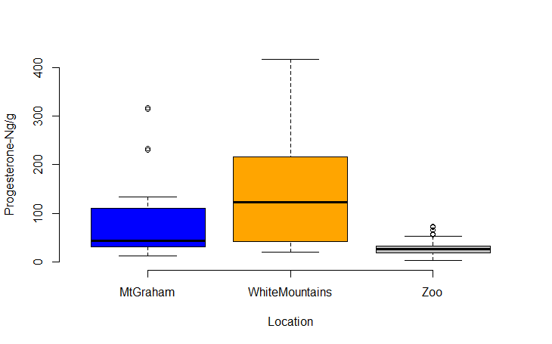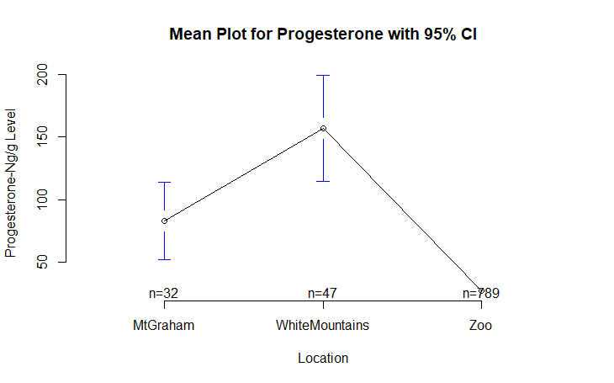

**Mean progesterone values for Zoo Mt. Graham red squirrels are significantly lower than that of in situ MGRS and WMRS – F=279.5 Pr<2e-16**

**Mean Progesterone values by season of both in situ and ex situ red squirrels:**

**Fall 28.4ng/g-Max/min-31712.9/, Spring, 31.7ng/g-Max/min-22/99.89, Summer, 36.6 ng/g-Max/min-485/6.14, Winter 47.1ng/g-Max/min- 532/7.31**

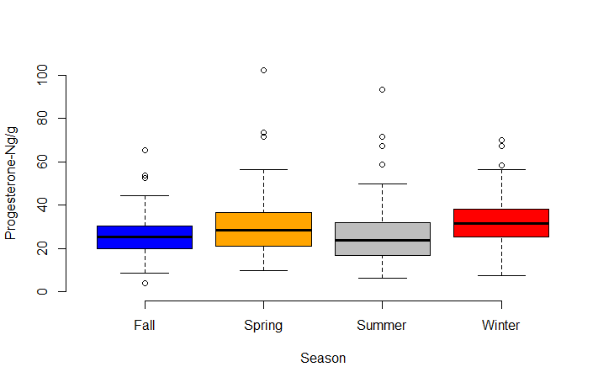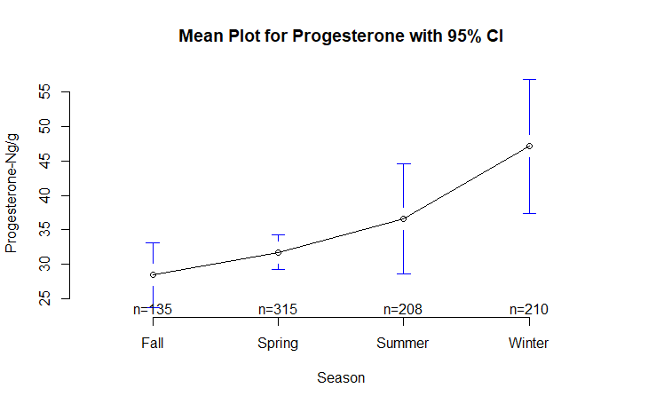

**Mean progesterone values are ? F 5.532 Pr>0.000917**

**Mean estradiol values of *in situ* red squirrels vs. Zoo Squirrels: Mt. Graham =155 ng/g-Max/min,1013/12.1, White mt.376ng/g- Max/min-3525/25.4, Zoo=103ng/g-Max/min,433/10.9**

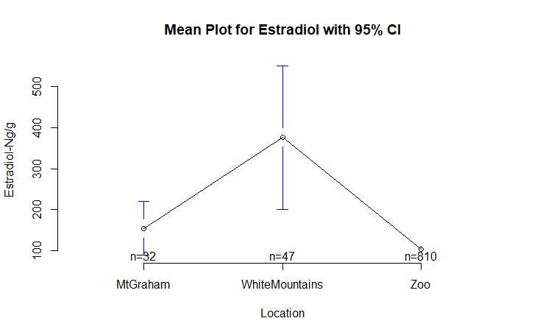

**Mean estradiol values for Zoo Mt. Graham red squirrels are significantly lower than that of in situ MGRS and WMRS – F=74.31, Pr<2e-16**

**Mean Estradiol values by season of both *in situ* and *ex situ* red squirrels:**

**Fall 112ng/g-Max/min-433/10.9, Spring, 98.2ng/g-Max/min-329/12.1, Summer, 118 ng/g-Max./min 1188/25.0, Winter 160ng/g-Max/min, 3525/15.9**

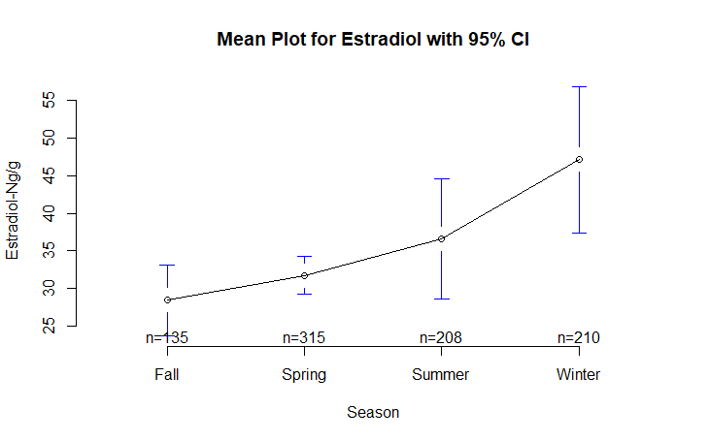

**Mean estradiol values for Zoo, and in situ red squirrels by season are significantly different – F=6.507, Pr>0.000235**

**Mean cortisol values of in situ red squirrels vs. Zoo Squirrels:**

**Mt. Graham =68.6 ng/g-Max/min,184/9.79, White mt.155ng/g-Max/min,895/17.4, Zoo=935ng/g-Max,1084/1.75**

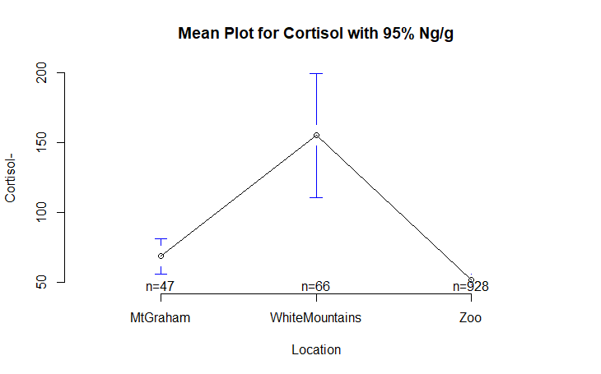

**Mean cortisol levels of Zoo MGRS are significantly higher than in situ red squirrels F=62.91 Pr <2e-16**

**Mean cortisol values by season of both *in situ* and *ex situ* red squirrels:**

**Fall 44.6ng/g-Max/min-592/8.65, Spring, 57.6ng/g-Max/min-612/3.40, Summer, 70.6 ng/g-Max/min- 1084/7.37, Winter 57.1ng/g-Max/min 893/1.75**

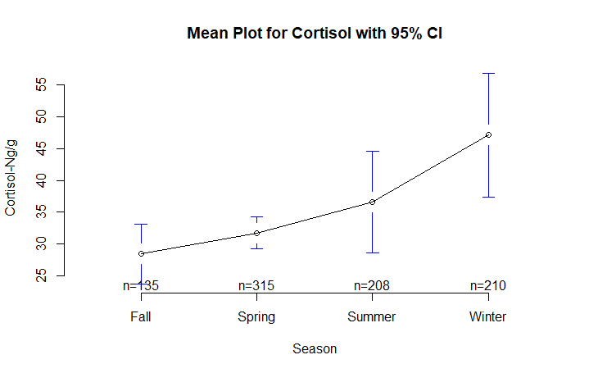

**Mean cortisol values for Zoo, and in situ red squirrels by season are (not?)significantly different – F=3.742, pr>0.0108**

**Mean testosterone values of in situ red squirrels vs. Zoo Squirrels:**

**Mt. Graham =127 ng/g-Max/min,270/34, White Mt.=112ng/g-Max/min,327/6.94 Zoo=93.1ng/g-Max,236/47.5**

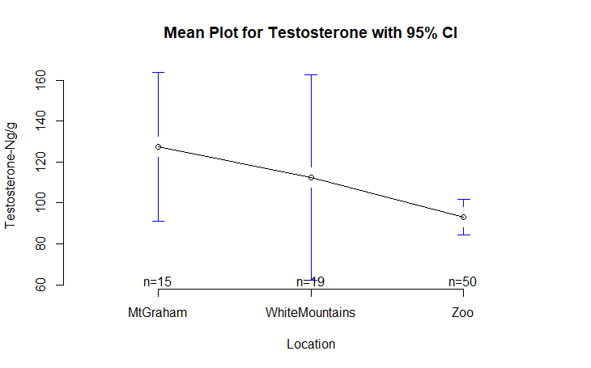

**Mean testosterone values for Zoo and in situ red squirrels are (not?)significantly different – F= 2.095 Pr> p 0.13**

**Mean testosterone values by season of both *in situ* and *ex situ* red squirrels:**

**Fall - na,* Spring, 103ng/g-Max/min,-236/34.0, Summer, 104 ng/g-Max/min, 327/6.94a, *Winter-na**

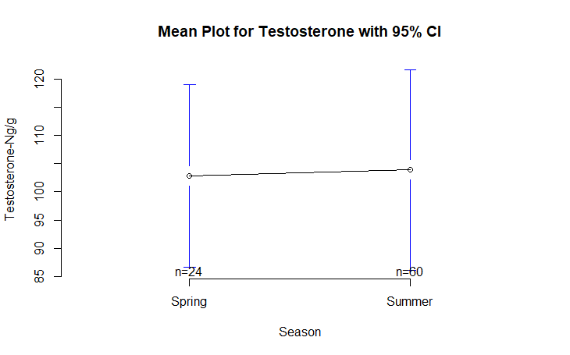

**Mean testosterone values by season for Zoo and in situ red squirrels are (not?)significantly F=0.005 Pr> 0.946**

**\*no samples were collected in the fall and winter**